NUST TEST BROCHURE
PART-16
FOR NUST TEST ONLY
2015

NET ENGLISH PART
MADE BY=NUSTIANS

‘
LEAKING,SHARING OR COPYING NUST BROCHURE TO ANYBODY BY ANY MEANS IS STRICTLY AGAINST THE COPYRIGHTS LAW OF 1898 OF LAHORE HIGHCOURT UNDER SECTION 15B,IF ANYBODY INDULGES IN ABOVE ACTIVITIES, DIRECT CASE WILL BE REGISTERED AGAINST HIM/HER IN HIGHCOURT & PRISON UPTO 1 YEAR & FINE ABOVE 60Ks WILL B AFFLICTED & NO EXCUSE WILL B ACCOMODATED THEN & YOU WILL BE RESPONSIBLE FOR YOUR OWN LOSS

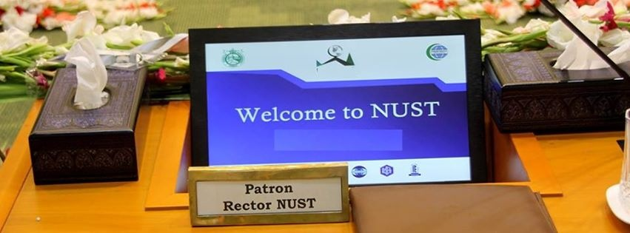
THIS PART CONTAINS PAST MCQS OF NET OF DIFFERENT YEARS.
NEVER COPY IT(STRICT COPYRIGHT LAW 1898 APPLIED)

(1) NET ENGLISH ANTONYMS(v.imp)
(CAME IN 2012,2014 SESSIONS OF NET)
NET ANTONYMS-(TEST OF 2011,2012,2013 & 2014)
1) NERVOUS
a)courageous b)puzzle
c)bold d)trainee
2) NOTORIOUS
a)renowned b)invicible
c)inactive d)fashionable
3) NOCTURAL
a)patrolling b)daily
c)harsh d)marauding
4) SINCERE
a)patient b)wreck
c)miserable d)pity
5) BEAUTY
a)ugly b)fair
c)average d)pretty
6) MAGNANIMOUS
a)large b)small
c)noble d)dignified
7) IMPORTED
a)qualitied b)professional
c)market goods d)local
8) RENT
a)car b)bike
c)class d)own
9) LEVEL
a)side b)back
c)right d)climax
10) KNOWN
a)like b)unlike
c)pretty d)anonymous
11) FUZZY
a)bright b)real
c)enlightened d)dull
12) VENIAL:
a)skillful b)bold
c)majestic d)un pardonable
13) ABHOR:
a)love b)unlike
c)same d)different
14) OBESITY:
a)pretty b)slim
c)good d)patience
15) ADULTERATE:
a)patch b)clean
c)lush d)better

16)He will meet her.......9 am.
A. to B. With
C. By D. At
ENGLISH ANALOGIES(v.imp)
(CAME IN NET (ENGLISH) IN 2011, 2012,2014 SESSIONS OF NET)
(1) TELLER:BANK
a)artist:MUSEUM (b)cashier:check
c)waiter:restaurant (d)mourner:funeral
(2) INNING:BASEBALL
a)puck:hockey b)serve:tennis
c)outing:hiking d)round:boxing
(3) DEGREE:TEMPERATURE
a)ounce:weight b)fathom:volume
c)mass:energy d)time:length
(4) EINSTEIN:PHYSICS
a)harvey:biology b)bohr:periodic table
c)moseley:chemistry d)aristotle:greek
(5) JACKET:LEATHER
a)shoes:laces b)shirt:cotton
c)pant:zip d)geometry:pen
(6) MOBILE:CALL
a)cycle:sit b)horse:nail
c)bike:ride d)car:dashboard
(7) BANK:STAFF
a)school:study b)boy :girl
c)woman:man d)school:teachers
(8) DOCTOR:PATIENT
a)shop keeper:things(b)mother:child
c)female:male (d)salesman:customer
(9) TURKEY:ISTANBOL
a) pakistan:islamabad b)india :new delhi
c)china: shangai d)iran :tehran
(10) BOOKS:STUDY
a)funfair:celeberate b)fridge :cold
c)year :work d)marry :children
(11) PICK:GUITAR
a)peg:ukele b)string: banjo
c)pipe: organ d)bow :violen

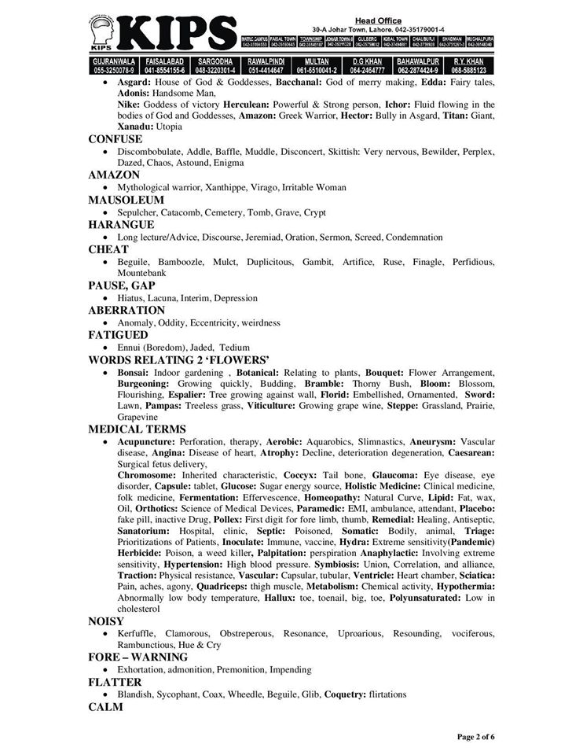
NET SYNONYMS/ANTONYMS
(TEST OF 2011,2012,2013)
Antonym of forlorn__(NET-2012)
pitiful hopeless
cheerful funy
Synonym of buxom is
despicable attractive
robust mild
Synonym of indiscrete
careful cautious
ruthless injudicious

Synonym of euphonious
song unmusical
harsh harmonius
Meaning of dire
Happy unwrightfully
awful ambitious
Opposite of enigmatic
unmysterious unclear
inscrutable unknown
Maunder means
wonder wander
troll brisk walk
Opposite of invalid
unsuitable unequal
applicable unconvincing
Succor is provided to the needy & wounded soldiers,succor is
shelter clothing
food help
Amateur means
paid part time
expert skilled
Conjure means
call summon
provoke magic
Baleful means
bale threatening
amusing dreadful
The meaning of capaious
bounded agile
wide awkward
Choose correct spelings
amperical empirical
perical empire
Choose the correct spelling:
presamble misible
presible permissible
Choose the correct spelling:
Prejudice jeduce
dejuice diceju
Choose the correct spelling:
qustion narequestion
naireques questionare
Choose the correct spelling:
conscience counsice
consice conscence
Choose the correct spelling:
locmotive locomotive
lecomotive lucomotive
ANALOGY
guest:motel
teacher:school
doctor: patient
actor : shop
ENGIMA
Like drill
Blurred mystery
ABHORE
Like detest
Noble negligible
AUGUST
View landscape
Flippant dignified

STINGY
Never always
Dump close-fisted
SPONTANEOUS
Sharp fast
Slow impulsive
AGGREGATE
Tabular discriptive
Silence accumulate
SLUGGISH
Knave skillful
Steal dull

ASCRIBABLE
Rascal bad
Renewable detectable
TRANQUILITY
Treaty war
Fight peace
SUMPTUOUS
Fast dragger
Ditch splendid
APPORTION
Flats homes
Division multiplication

APPRISE
Saying ordering
Advising calling
ARTFUL
Artist better
Skillful dashing
CAPACIOUS
Following right
Viewing abundant
DOWDY
Pretty sexy
Friendly old fashioned

CALM
Warry assuming
Impulsive queit
BLEMISH
Flaw slum
Sad minimum
PAUPER-(NET,16 JUNE-2011)
Begger rich
middle class odd
AUDACIOUS
Brunt pressure
trouble some lively spirited

ELLICIT
Impulsive dashing
Key evolve
FLEECE
Excess leveled
Steal bought
